**Panel Econometrics**

Assignment #4

By Chuxin Liu

**Question 1: Compute and report the descriptive statistics (means and standard deviations) for the twelve variables.**

Table 1: Summary Statistics

|  |  |  |
| --- | --- | --- |
|  | (1) |  |
|  | Total sample |  |
|  | mean | sd |
| exp | 19.85378 | 10.96637 |
| wks | 46.81152 | 5.129098 |
| occ | .5111645 | .4999354 |
| ind | .3954382 | .4890033 |
| south | .2902761 | .4539442 |
| smsa | .6537815 | .475821 |
| ms | .8144058 | .3888256 |
| fem | .112605 | .3161473 |
| union | .3639856 | .4812023 |
| ed | 12.84538 | 2.787995 |
| blk | .0722689 | .2589637 |
| lwage | 6.676346 | .4615122 |
| *N* | 4165 |  |

**Question 2: Replicate the results of Table 7.4 (you may use Stata’s built-in commands: xtreg and xthtaylor)**

Table 7.4 on Baltagi’s book:

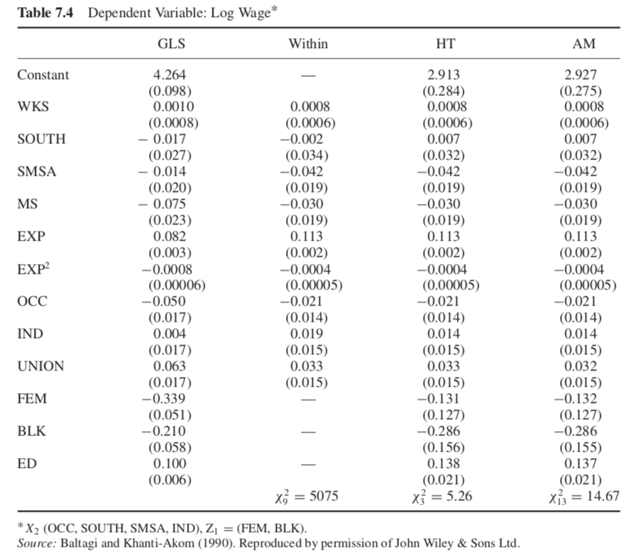

Table 2: Replication of Table 7.4

|  |  |  |  |  |
| --- | --- | --- | --- | --- |
|  | (1) | (2) | (3) | (4) |
|  | GLS | Within | HT | AM |
| Constant | 4.264*** | 4.649*** | 2.913*** | 2.927*** |
|  | (0.0977) | (0.0460) | (0.284) | (0.275) |
| WKS | 0.00103 | 0.000836 | 0.000837 | 0.000838 |
|  | (0.000773) | (0.000600) | (0.000600) | (0.000599) |
| SOUTH | -0.0166 | -0.00186 | 0.00744 | 0.00728 |
|  | (0.0265) | (0.0343) | (0.0320) | (0.0319) |
| SMSA | -0.0138 | -0.0425* | -0.0418* | -0.0420* |
|  | (0.0200) | (0.0194) | (0.0190) | (0.0189) |
| MS | -0.0746** | -0.0297 | -0.0299 | -0.0301 |
|  | (0.0230) | (0.0190) | (0.0190) | (0.0190) |
| EXP | 0.0821*** | 0.113*** | 0.113*** | 0.113*** |
|  | (0.00285) | (0.00247) | (0.00247) | (0.00247) |
| exp2 | -0.000808*** | -0.000418*** | -0.000419*** | -0.000421*** |
|  | (0.0000628) | (0.0000546) | (0.0000546) | (0.0000546) |
| OCC | -0.0501** | -0.0215 | -0.0207 | -0.0208 |
|  | (0.0166) | (0.0138) | (0.0138) | (0.0138) |
| IND | 0.00374 | 0.0192 | 0.0136 | 0.0136 |
|  | (0.0173) | (0.0154) | (0.0152) | (0.0152) |
| UNION | 0.0632*** | 0.0328* | 0.0328* | 0.0325* |
|  | (0.0171) | (0.0149) | (0.0149) | (0.0149) |
| FEM | -0.339*** | 0 | -0.131 | -0.132 |
|  | (0.0513) | (.) | (0.127) | (0.127) |
| BLK | -0.210*** | 0 | -0.286 | -0.286 |
|  | (0.0580) | (.) | (0.156) | (0.155) |
| ED | 0.0997*** | 0 | 0.138*** | 0.137*** |
|  | (0.00575) | (.) | (0.0212) | (0.0206) |
| Hausman |  | chi2(9)=5075 | chi2(8)=5.26 | chi2(12)=14.67 |

*X2(exp exp2 wks ms union), Z1(fem blk)

Source: Baltagi and Khanti-Akom (1990)

**There is slight difference between replication and original table:**

1. My replication FE model estimates constant term while the original FE model doesn’t;
2. In terms of Hausman test for (FE vs HT) and (HT vs. AM): my replication is able to match the statistics, but cannot match the degree of freedom.

**Question 3: How many instruments does each of the two HT regressions use, and thus what are the degrees of freedom of the test for overidentification?**

????

**Question 4: Compare the RE (or GLS), FE (or WE), and AM estimators: do the proper HT and Hausman tests to figure out your recommended estimator.**

1. FE vs. RE (significant)

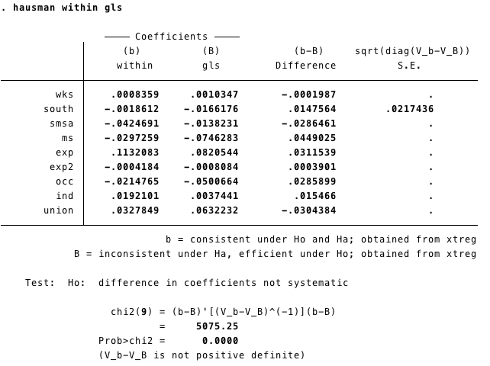

1. FE vs. HT (insignificant)

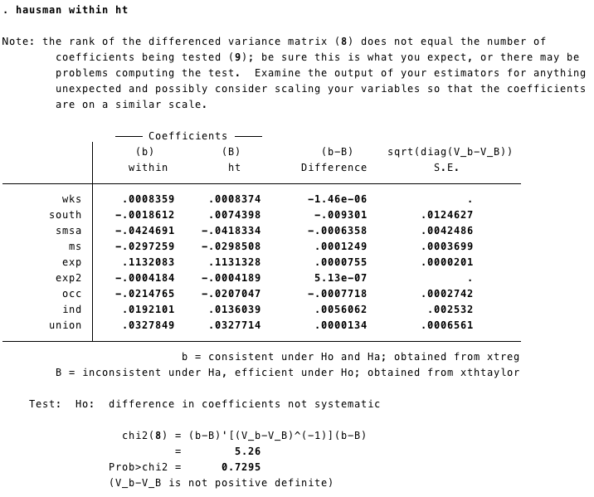

1. RE vs. HT (significant)

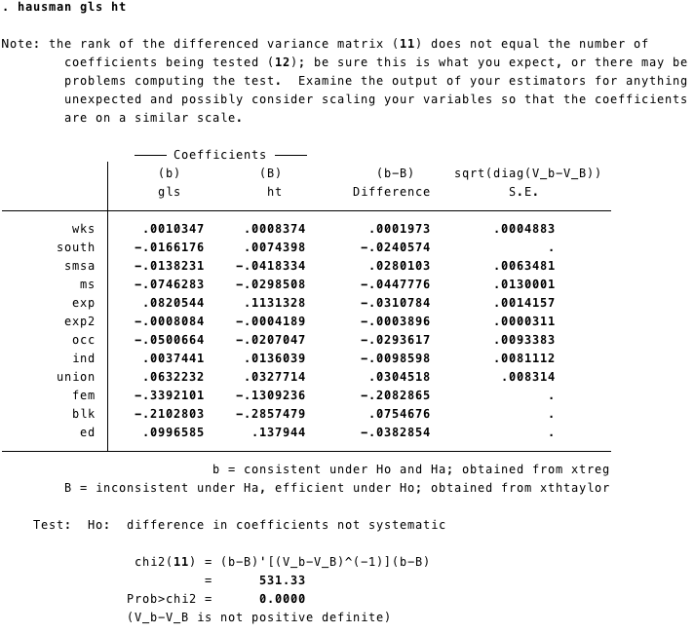

1. HT vs. AM (insignificant)

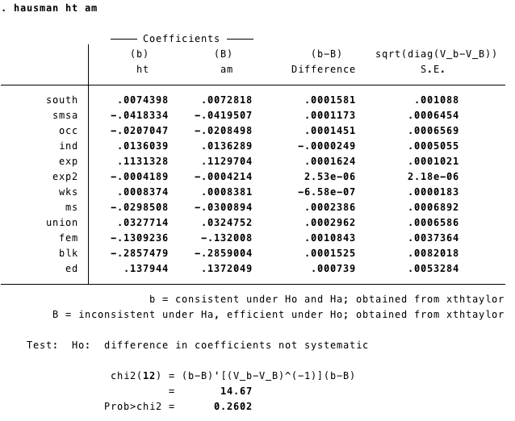

**Appendix: STATA Codes**

